**Stoney Lake Dance Weekend Musicians**

**Don Bartlett**

Don was born in Toronto. His family includes a strong legacy of church musicians including Henry T. Smart, who wrote “Angels from the Realms of Glory” and many other hymns.

Don grew up in Scarborough and attended Fallingbrook Presbyterian Church, where Hughina Wilson taught SCD to children on Saturday mornings. He enjoyed the dancing, the music, and the sociability. His favourite recordings were by Stan Hamilton & The Clansmen (later The Flying Scotsmen).

Dancing was great, but Don wanted to play the music, too. Hughina gave him the RSCDS Graded Book with music, and, with little musical training, he struggled to learn his first tune (a jig, Lord Cathcart). Jean Anderson, Bobby Brown's sister, gave him valuable tips. Before long he learned his first strathspey, Mrs. Stewart Nicholson — the only tune he had both on paper and on a recording (Stan Hamilton's).

Soon Don, still in his teens, was playing for many events as a solo pianist and as a member of Angus MacKinnon’s band—one of three bands active in Toronto at that time. He played for dance weekends, workshops, and special classes, including classes with Miss Milligan. With Angus McKinnon, he played for grand balls from New York to Montreal.

In 1972 Don formed his own band, The Scotians. Even though there were now four bands in Toronto, Don was called to play 60 to 70 events a year. Certain tracks on his Don Bartlett & The Scotians recordings are the gold standard for particular dances around the world. (Don’s Davy Nick Nack is particularly famous.) These days the band is Don Bartlett & The Scottish Heirs, and it includes his daughter Jacquie on fiddle, daughter Lesley on electric bass, and friend Blair Mackenzie on fiddle. In 2020, Don recorded a solo piano CD, a few copies of which are still available. Don finds great pleasure in passing the wonderful heritage of Scottish country dance music along to his daughters, and to dancers of all ages.

**Blair Mackenzie**

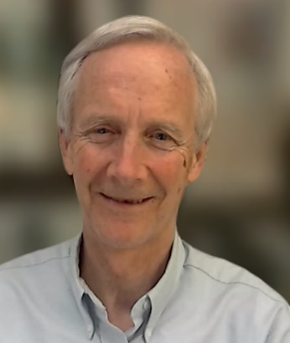

Blair is a retired lawyer who has played violin and viola for many years.   He plays weekly at PSCDS dance practices.   He and Helen Batten provide live music for all PSCDS monthly dances.   He plays occasionally for Scottish Country dancing at other locations in Ontario as a member of Don Bartlett's band, Don Bartlett and the Scottish Heirs.   Blair and his wife Kathleen, a keen dancer, live in Lakefield, Ontario.