

**Duncan Keppie** has been teaching Scottish Country Dance (SCD) workshops and classes for many years in various countries such as Scotland, the U.S., Zambia, New Zealand, Mexico and Canada at the Gaelic College and Haliburton School of Arts. Duncan and Maggie (wife) have composed and published more than 350 Scottish Country dances in the Gaelic College, Haliburton Series and the Scottish Dance Dictionary. Duncan is author of a highly successful and detailed dance manual, and a book and recording entitled *The Music Tells You What To Do*. Duncan plays the piano accordion for Scottish Country dancing and has two recordings with the Macadians SCD Band. Participants’ experience of SCD opens a rich vista of how SCD was danced prior to the twentieth century, and recent innovations in the SCD tradition. This interest will be highlighted at the Peterborough weekend with the inclusion of several recent formations including turn 2nd-corner-partner-1st corner-partner, Hand-in-Hand reels, the Ancient Poussette, and the Rigg, thereby keeping the tradition “alive”.

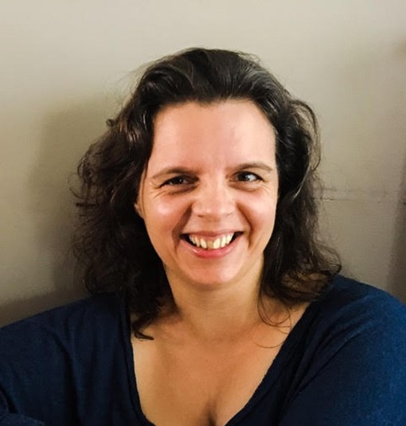

**Ailsa Keppie** has been immersed in Scottish dancing and music from birth, initially absorbing the culture by osmosis and then joining her parents and Scottish Country dance events. This experience progressed on going to the St. Ann’s Gaelic College to learn Highland Dancing and Cape Breton Step Dancing. Ailsa was a member of the St. Andrew’s University demonstration team while she was studying in Scotland in the 1990’s. **Ailsa** is a Registered Massage Therapist with additional expertise in Myofascial Release and Craniosacral therapy. This, combined with her SCD experience, provide her with knowledge about how to keep dancing over the years, information she will teach at the weekend.

**Ailsa’s Sustainable Movement Session**

Interested in prolonging your days of dancing? Wish you had more *understanding of the body so you could feel more energetic and prevent injuries?*Ailsa will offer a Pilates and Somatic awareness-based class with precise exploration around correct alignment for ease and strength. This class can be done with modifications by people with mobility issues or injuries. Ailsa is a trained RMT, Yoga teacher and Exercise Instructor. Please wear comfortable, loose clothing and **bring a yoga mat if you have one**.