**GARRY STRATHSPEY**

Named after the Garry River in Perthshire “POSS-IB-LY”, as it’s danced to the adapted mu-zac of “The Jigtime Polka” by one Jimmy Blair of the “Stonehouse Accordion & Fiddle Club”. It just happens PERCHANCE that Jimmy’s brother GARY is also a band member, but as the dance is spelt GARRY we presume it’s for the river.

**GARRY RIVER, PERTHSHIRE**

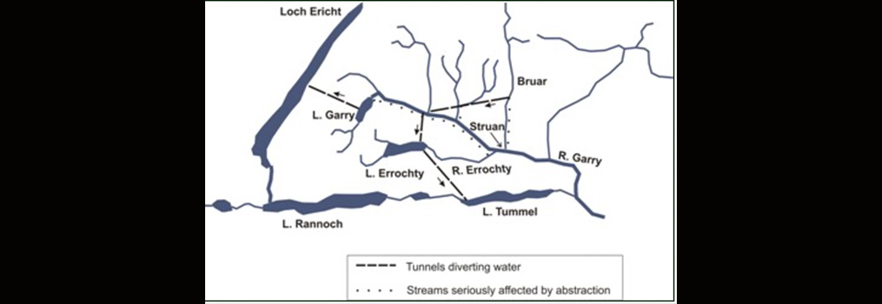 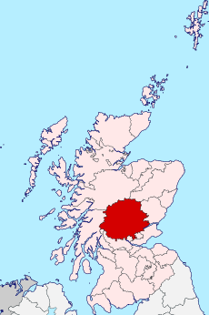

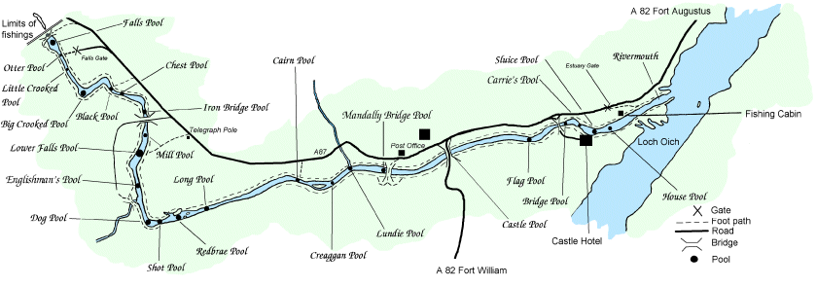

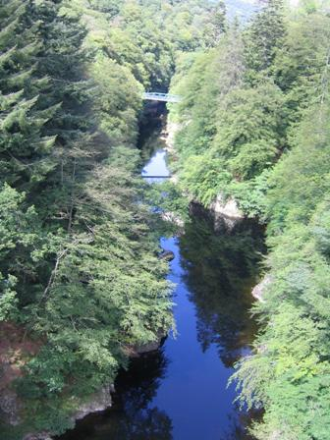 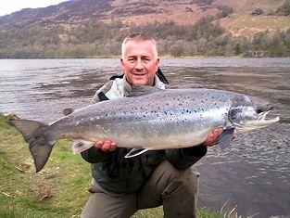

**BATTLE OF KILLICRANKIE 1689, 1st Jacobite Rebellion aka “Williamite War” 1689-91**

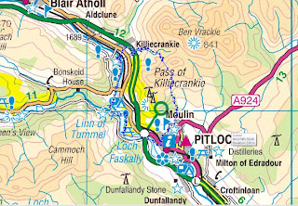 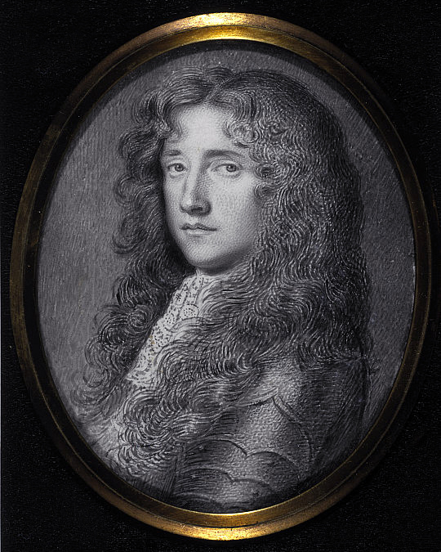

JOHN GRAHAM, 7th Laird of Claverhouse, was made 1st Viscount Dundee for his services to the crown. However he then supported the “Jacobite” cause leading the rebels to victory at “The Battle of Killiecrankie” but died on the field. In previous battles he was know for throwing his bonnet up in victory, and a poem by Sir Walter Scott 1825 would give him a colourful title by which he would forever be known “BONNY DUNDEE”!

To the Lords of Convention ’twas Claver’se who spoke.  
‘Ere the King’s crown shall fall there are crowns to be broke;  
So let each Cavalier who loves honour and me,  
Come follow the bonnet of Bonny Dundee.

Come fill up my cup, come fill up my can,  
Come saddle your horses, and call up your men;  
Come open the West Port and let me gang free,  
And it’s room for the bonnets of Bonny Dundee!’

[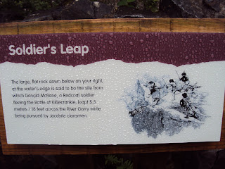](http://4.bp.blogspot.com/_IHTeN2Or7oo/TGmm_o460FI/AAAAAAAAAMI/NwpPtp_uu0k/s1600/DSC00582.JPG) [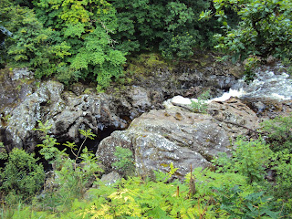](http://4.bp.blogspot.com/_IHTeN2Or7oo/TGmoZBM4dkI/AAAAAAAAAMQ/LO1YldNjc9Y/s1600/DSC00583.JPG)

 The falls where Donald McBane is alleged to have jumped over escaping after the battle.