**Monymusk (Scottish Gaelic: Monadh Musga)**

Monymusk is a planned village in the Marr area of Aberdeenshire, Scotland, 50k NW of Aberdeen. The name is Gaelic “moine mus(g)ach” (nasty, filthy bog), not perhaps THEE most prepossessing of names. A nicer alternative for “Monymusk” (or “Monimusk”) can also be based on the Gaelic “monadh” meaning a moor or heath and “uisge” meaning water or river.

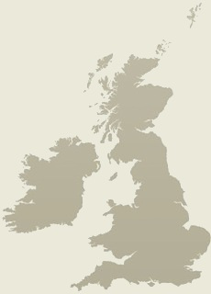 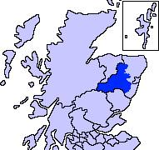 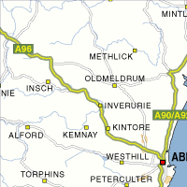

The striking mountain range of Bennachie lies 7 miles to the North of Monymusk and dominates the local landscape with its distinctive volcanic shaped peak - the Mither Tap. Despite this shape, it was never a volcano, but the peak has been the inspiration behind many local legends.

The Bennachie range was formed 400 million years ago by a mass of sedimentary rock pushing upwards in the earth's crust. It cooled slowly under a mass of sediment which has gradually worn away to expose the granite underneath. There are 6 main peaks on the range, which are made of harder granite and have been able to resist the weathering and ice better. Some of the peaks have exposed rock, which are known to geologists as tors. Mither Tap is a tor and the most prominent of the peaks on the Bennachie range, yet the highest point is the Oxen Craig at 528 m.

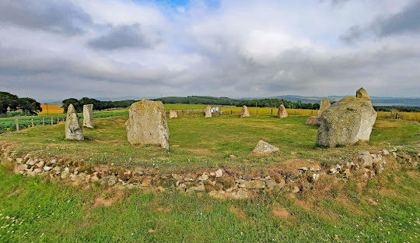

East Aquhorthies Stone Circle

Malcolm Canmore ( [Malcolm III](https://www.undiscoveredscotland.co.uk/usbiography/monarchs/malcolmiii.html) of Scotland) first established a [Celtic foundation on the site in 1078](https://canmore.org.uk/event/668983). He passed through Monymusk while en route to defeat [Lulach,](https://www.undiscoveredscotland.co.uk/usbiography/monarchs/lulach.html) son of [Macbeth,](https://www.undiscoveredscotland.co.uk/usbiography/monarchs/macbeth.html) an encounter which took place on 17 March 1058. While here, he stopped to pray at an already ancient Celtic church in the village and promised that, if successful in battle, he would build a tower for the church. He was, and he did.

The Culdees of Munimusc are recorded as inhabiting the site in 1170. [Monymusk Priory](https://en.wikipedia.org/wiki/Monymusk_Priory" \o "Monymusk Priory), an Augustinian priory, was built by Gilchrist, Earl of Mar, around 1200 the remains of which have now disappeared. Later the church formed the heart of an Augustinian Priory founded here, a fact which helps explain the enormous length of what was originally the chancel (but is now a burial enclosure). The priory continued in being until much of it was damaged in a fire in the early 1500s. The Prior, John Elphinstone, was subsequently tried in [Aberdeen](https://www.undiscoveredscotland.co.uk/aberdeen/aberdeen/index.html) on a range of charges including murder and arson. After the [Reformation](https://www.undiscoveredscotland.co.uk/usscotfax/history/reformation.html) in 1560, what was left of the priory was acquired by the Forbes family together with the surrounding estates. They built the nearby House of Monymusk in 1584 using stones of the priory and lived there until the sale of the estate to the Grants in 1712. Meanwhile, the priory church was restored and rebuilt as a parish church, a role it continues to fulfil today, albeit in a form that has seen many changes over the centuries.

Duncan Forbes, second son of Duncan Forbes of Corsindae, had advanced large sums on the Priory lands of Monymusk, having a charter from Pope Julius III to “set the Mains of Monymusk.” (Tayler, Alistair and Henrietta. 1937. *House of Forbes*. Edinburgh: Third Spalding Club.) After the Reformation Parliament that outlawed the practice of Catholic worship in Scotland, Forbes foreclosed on the mortgage. He therefore gained the estate by charter and founded the cadet branch [Forbes of Monymusk](https://www.clan-forbes.org/post/forbes-of-monymusk). He built the central tower adjacent to the old Priory using stones and beams from the burned priory. (*Monymusk Papers 1713-1755*, edited by Henry Hamilton, page xi.)

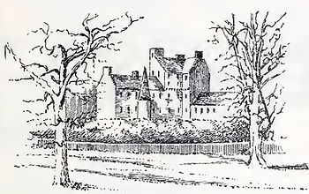 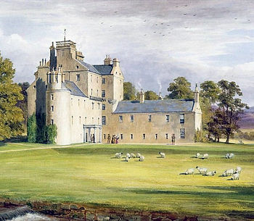

LEFT: Monymusk House, sketched by Archibald Robertson in 1780, published in "Castellated and Domestic Architecture of Scotland," volume 5, in 1842.

RIGHT: Monymusk House, by James Williams Giles, 1848

In 1589, his eldest son and heir, William Forbes, second laird of Monymusk, obtained a Crown Charter erecting the town and lands of Monymusk into a borough of barony. His heir, also named William, bought additional land and was created a baronet by Charles I in 1626. This was among the earlies baronetcies in Scotland. (Tayler, Alistair and Henrietta. 1937. *House of Forbes*. Edinburgh: Third Spalding Club.). During the Scottish Civil War between the Covenanters and Royalists, Sir William, 4th Laird and 2nd Baronet, joined Covenanter Archibald Campbell, the Marquis of Argyll, at Dunnottar Castle in April, 1644. He was still in the field when the opposing Royalist Commander James Graham, 1st Marquess of Montrose, marched on Monymusk. However, Montrose spared the estate due to the hospitality of Sir William’s wife Jean Burnett of Leys: “Upone Setterday the 19 of October, he dynit in Monymufk with the ladie, the laird being absent, and upone fair conditionis he spairit him at this tyme.” (Spalding, John. 1792, reprinted 1829. *The History of the Troubles and Memorable Transactions in Scotland and England from 1624 to 1645*. Edinburgh: Bannatyne Club.)

Unfortunately, his grandson, Sir William Forbes, the 4th Bart. of Monymusk, was not likewise able to save the Monymusk Estate. In 1712, he became bankrupt and sold Monymusk to Sir Francis Grant, Lord Cullen, for £96,000 Scots (£9,600 sterling). (Tayler, Alistair and Henrietta. 1937. *House of Forbes*. Edinburgh: Third Spalding Club.) The estate included the [Monymusk Reliquary.](https://www.clan-forbes.org/monymusk-reliquary)

Cullen made his son Archibald the factor on his 20th birthday in 1716. Over the next 62 years, Archibald Grant, later Lord Cullen, 2nd Baronet, vastly improved Monymusk house and the estate. (“Monymusk.” Historic Environment Scotland. [portal.historicenvironment.scot/designation/GDL00289](http://portal.historicenvironment.scot/designation/GDL00289).) Sir Archibald's great-grandson Robert Grant remodeled the house and undertook improvements to the farm buildings.

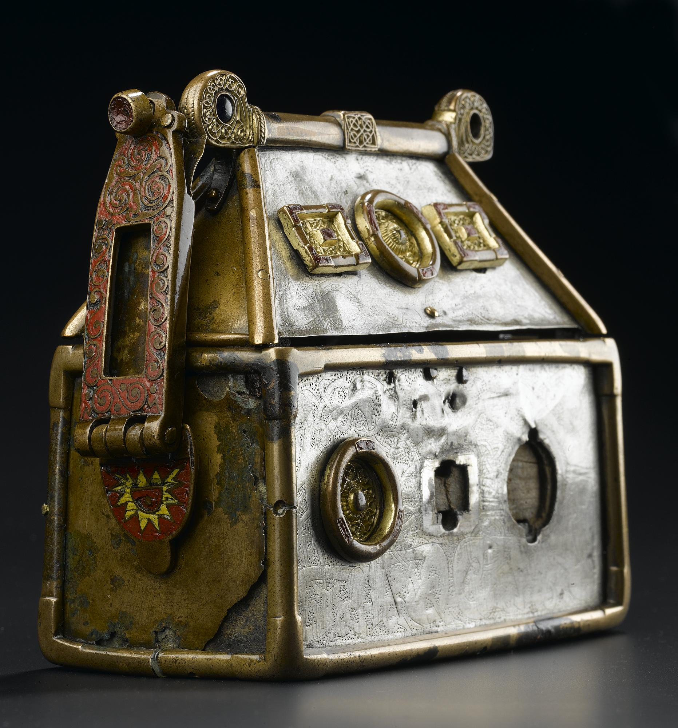

The Monymusk Reliquary - The Brecbennoch

When the Grants purchased the estate from the Forbes, one of the items included in the sale was a small wooden box decorated in silver stored in the House of Monymusk. The Monymusk Reliquary is believed to have been made by monks on [Iona](https://www.undiscoveredscotland.co.uk/iona/iona/index.html) in about 750, and is believed to contain one or more of the bones of [St Columba.](https://www.undiscoveredscotland.co.uk/usbiography/c/stcolumba.html) As a sacred battle ensign of Scotland, the Monymusk Reliquary is believed to have been shown to the Scottish troops before their victory over the English at the [Battle of Bannockburn](https://www.undiscoveredscotland.co.uk/stirling/bannockburn/index.html) in 1314. The Grants put the Reliquary on sale in 1933 and it was purchased for the nation. It is now on display in the [National Museum of Scotland.](https://www.undiscoveredscotland.co.uk/edinburgh/nms/index.html)

An interesting link between St. Columba and Monymusk is found in the form of the 'Monymusk Reliquary' or the 'Brecbennoch', a small casket that was preserved at Monymusk House for over 600 years. In 1933 it was put on sale at Christies in London by Sir Arthur Grant (11th Bt.) and received a great deal of public interest, as it was identified by scholars as being the Brecbennoch. The Brecbennoch was thought to have been used to bless the Scottish Army before the famous battle of Bannockburn in 1314, in which King Robert the Bruce defeated the English. It was also believed to have once contained some small bones of St. Columba, or have been a gift from the Saint himself.

The Monymusk Reliquary belongs to a small group of early Irish and Scottish house-shaped reliquaries, of which nine examples survive. From its ornamentation, it is thought to have been made towards the beginning of the 8th Century. The casket is carved from a solid piece of wood, and covered in bronze and silver plates carved with animals. It is decorated with bronze medallions bordered in a red glaze, and has one remaining enamelled hinge from the original two, which would have been pierced to take a carrying strap so that it could be worn around the neck.

The Monymusk Reliquary is widely believed to be the Brecbennoch, and is currently depicted on Clydesdale Bank 20 pound notes. However, there are some who believe that the Monymusk Reliquary may not be the Brecbennoch (Caldwell, David H.;The Monymusk Reliquary; the Breccbennach of St Columba?, Proceedings of the Society of Antiquaries of Scotland, 2001, (Paper) Proc Soc Antiq Scot, 131 (2001), 267-282). There is much evidence given in support of the theory that it is the genuine relic, but as yet no conclusive proof that it isn't.

The Celtic name Brec-bennoch has been translated in Gaelic as both 'the blessed shrine' or 'the speckled, peaked one'. **Breac** means either house-shaped, peaked or speckled, referring to its ornamented appearance. **Bennoch** means 'blessed'. The Brecbennoch was linked to the lands of Forglen, in that whoever owned the lands of Forglen also took on the role of custodian. It is believed it was the duty of the custodian of the Brecbennoch to carry it before the Scottish army before they went into battle. The custodian would bless the soldiers and their arms, pray for victory and show them the Brecbennoch. It is thought that the Brecbennoch came to be linked to the lands of Forglen when it was taken there by St. Eunan (i.e. Adomnan), a 7th Century abbot of Iona and biographer of St. Columba, who founded the church of Forglen in Banffshire.

King William I granted the lands of Forglen, and perhaps the custody of the Brecbennoch, to Arbroath Abbey in 1211 but the Brecbennoch probably often went between Arbroath and Forglen during this time. It is known that the Abbot of Arbroath was present at the famous Battle of Bannockburn in 1314 and it is therefore presumed that the Brecbennoch was used to bless the army before this battle. Over the Centuries there have been many different custodians of the Brecbennoch. In 1315 the Lands of Forglen and custody of the Brecbennoch were given to Thomas de Monimusk by King Robert the Bruce. The de Monimusk family may have lived in a tower which is now part of the present House of Monymusk, which might explain how the Brecbennoch first came to Monymusk. It was then passed to the Irvines of Drum, the Urries, the Frasers, the Forbeses and finally the Grants, who moved to Monymusk in 1713.

When the Brecbennoch was put up for sale by the Grants in 1933 to pay for death duty, the Scottish people and their relatives all around the World were urged by the *The National Museum of Antiquities of Scotland* to raise the money by subscription to secure the casket for the Nation. This was achieved, and it has been housed in the Museum of Scotland in Edinburgh ever since.

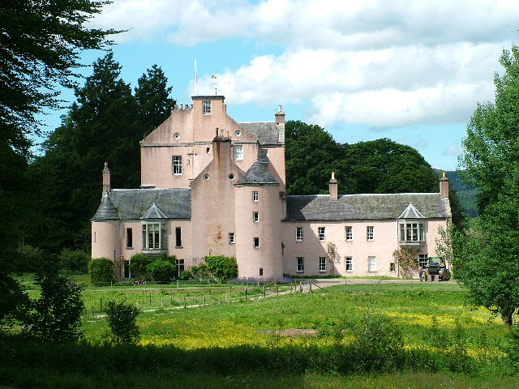

On the banks of the Don, amidst the “Woods of Paradise”, stands the House of Monymusk. The central tower was built by William Forbes about 1587 and the house stayed with the Forbes of Corsindae family until it was purchased in 1712 by Sir Francis Grant, Lord Cullen of Session.

[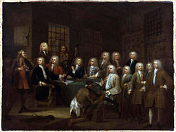](https://en.wikipedia.org/wiki/File:The_Gaols_Committee_of_the_House_of_Commons_by_William_Hogarth(2).jpg)

Sir Archibald Grant (standing third from the right) commissioned this painting from [William Hogarth](https://en.wikipedia.org/wiki/William_Hogarth)

Having been expelled from Parliament for fraud in 1723, burdened with a decaying house and an unprofitable estate, Sir Alexander turned his attention to Monymusk and through his determined and often ruthless efforts became one of the great agrarian improvers of the 18th century.

[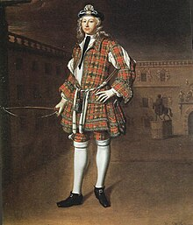](https://en.wikipedia.org/wiki/File:Archibald_Grant_of_Monymusk,_Royal_Company_of_Archers,_1715_by_Waitt.jpg)

The young Grant in [Royal Company of Archers](https://en.wikipedia.org/wiki/Royal_Company_of_Archers) uniform, as painted 1715 by [Richard Waitt](https://en.wikipedia.org/wiki/Richard_Waitt)

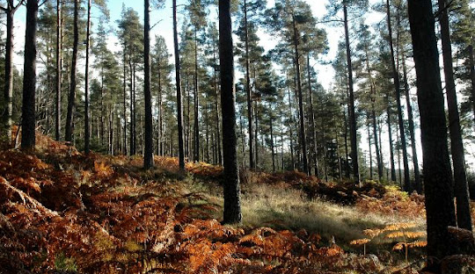

His son, Sir Alexander Grant, 3rd Baronet of Monymusk (d. 1796), planted the famous woods, fifty million trees in fifty years, certainly an arboreal record.

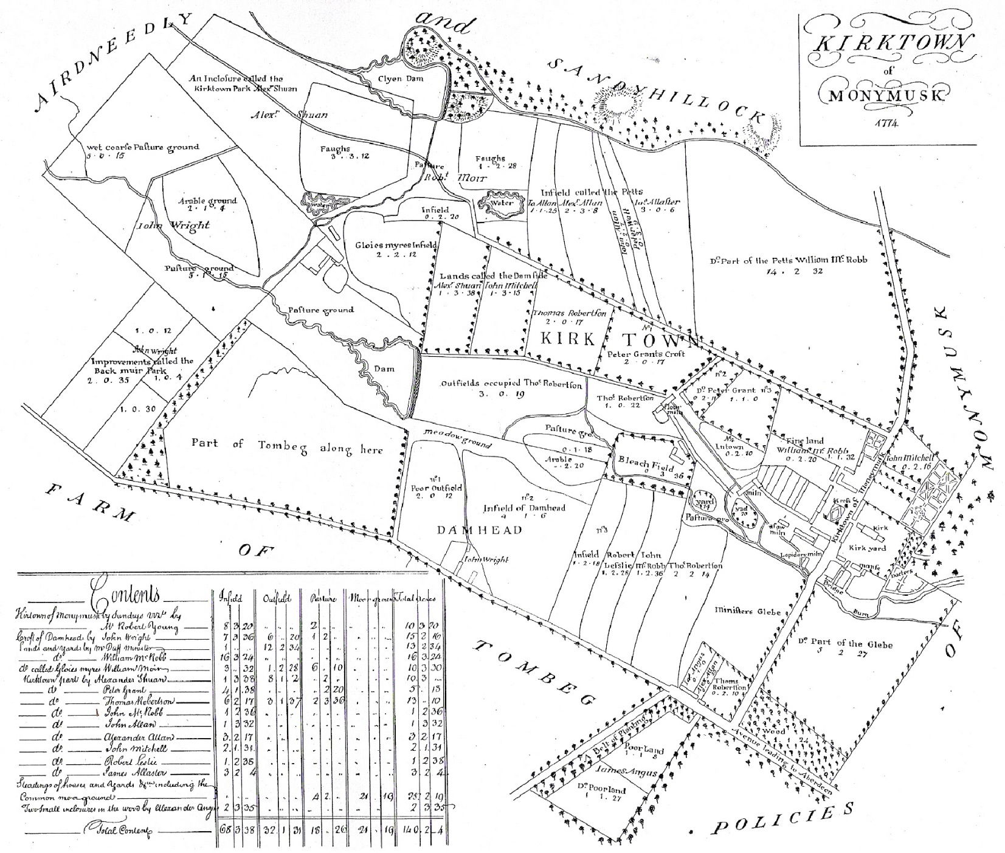

Nether Mains Farm in in SE Monymusk

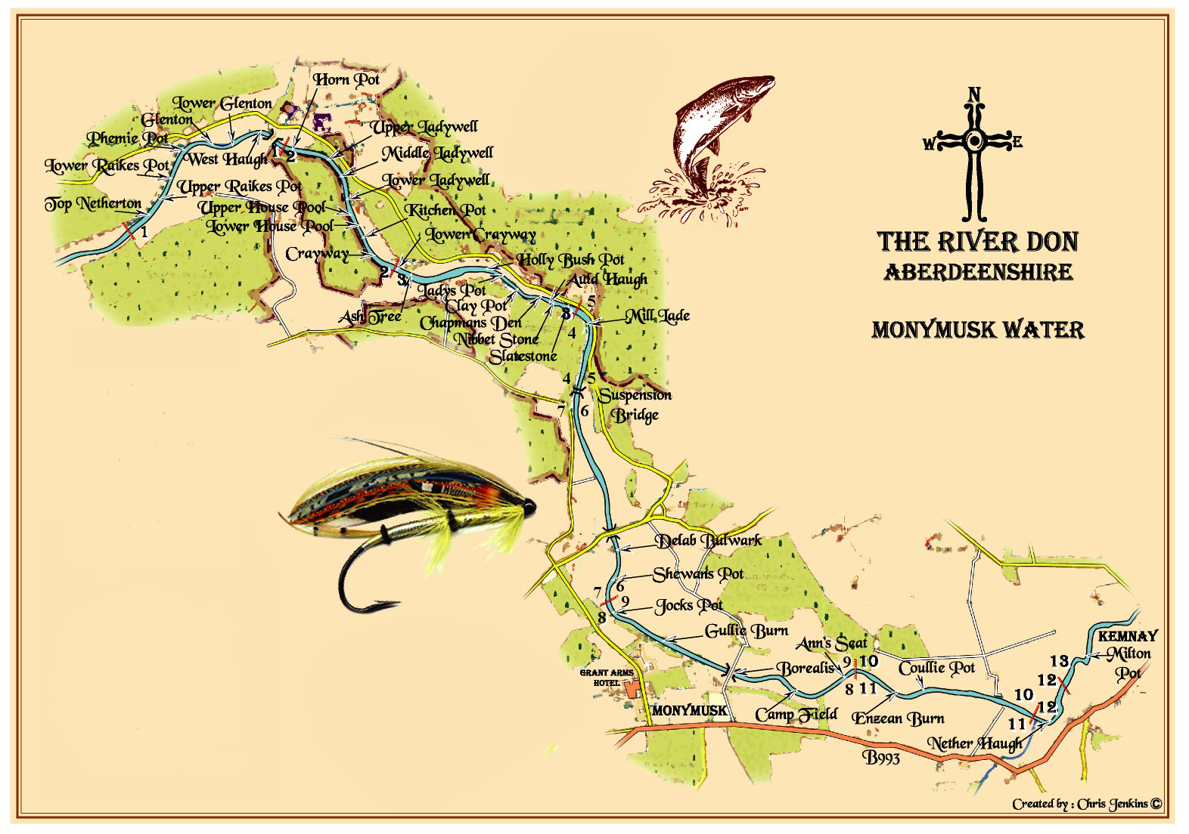

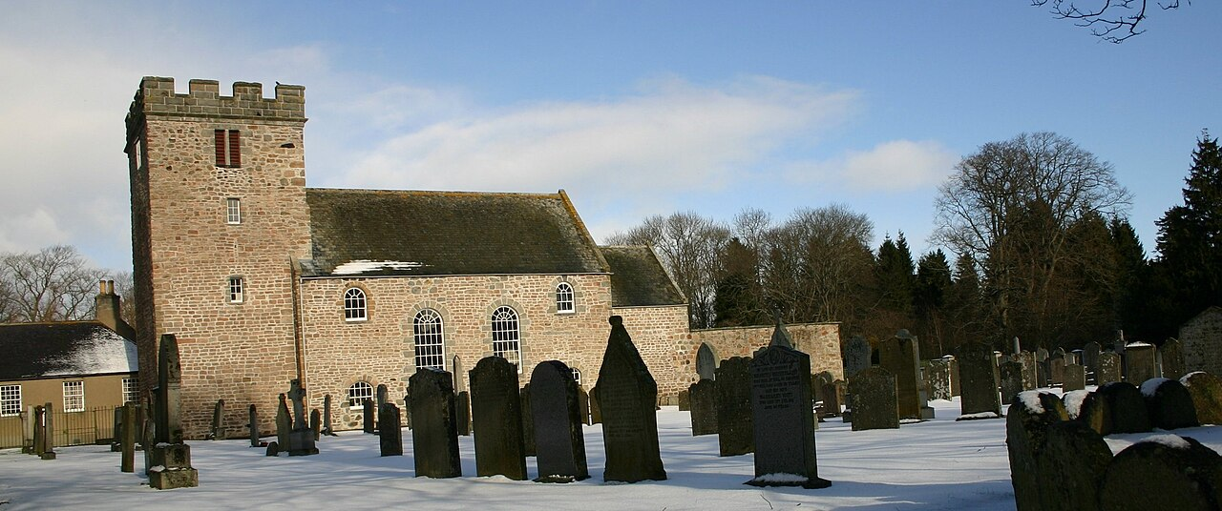

In the village of Monymusk is the ancient church with its Norman chancel arch, one of the finest churches in the northeast of Scotland. The estate passed from the Forbes family to the Grant family in 1712, and Sir Archibald Grant established a planned village for estate workers. [Monymusk Parish Church](https://en.wikipedia.org/wiki/Monymusk_Parish_Church" \o "Monymusk Parish Church) today occupies the location. The village was largely rebuilt again in 1840.[[1]](https://en.wikipedia.org/wiki/Monymusk#cite_note-gaz-1)[[2]](https://en.wikipedia.org/wiki/Monymusk#cite_note-gaz2-2)

Gavin Douglas (c. 1475–1522), the poet and translator of Virgil’s *Aeneid*, was a priest at the church there. For a time the Reverend John Skinner (1721–1807) taught school there and wrote “The Monymusk Christmas Ba’ing”, a long poem concerned not with religion but with a football match. (See also “The Crooket Horned Ewie” and “Tulloch Gorm”)

A 1776 [strathspey](https://en.wikipedia.org/wiki/Strathspey_(dance)) was named after the estate using the lead tune “Sir Archibald Grant of Monymusk”. This is one of the great Strathspey tunes, composed by that very original composer in the traditional idioms, Daniel Dow (1732–83), music teacher in Edinburgh. The laird of this territory in Aberdeenshire is Grant, Baronet of Monymusk. The Third Baronet, who died in 1796, is doubtless the one honoured by Daniel Dow.

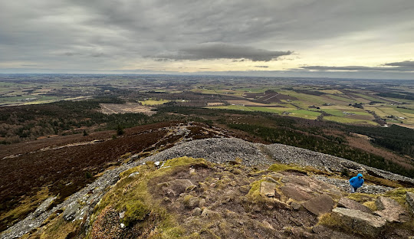 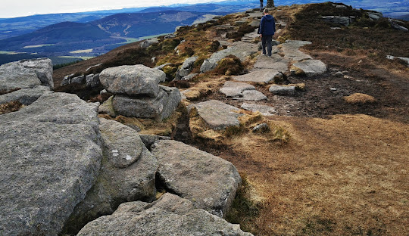

BENNACHIE OXEN CRAIG, Highest point 528m

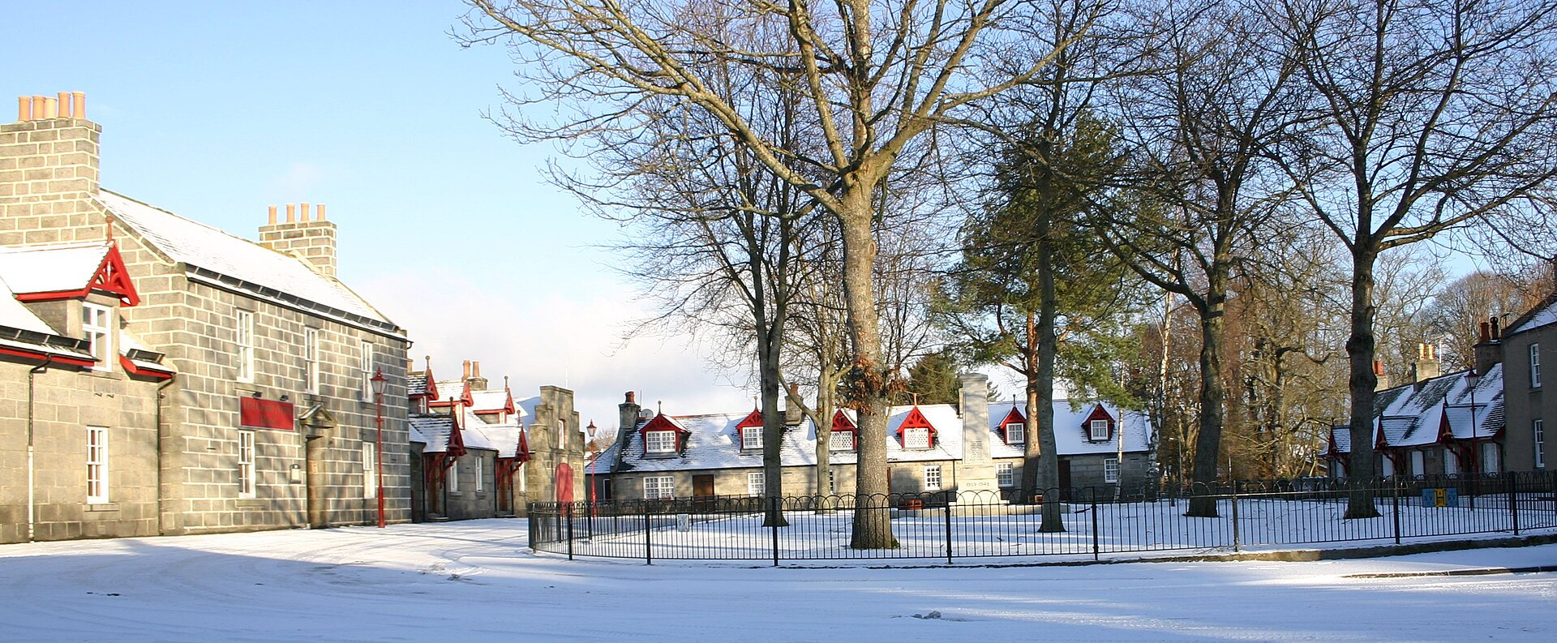

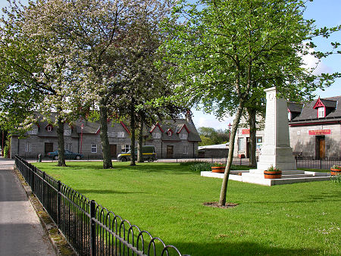

VILLAGE SQUARE

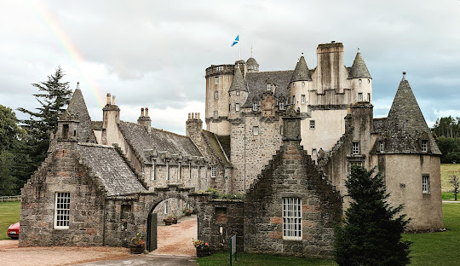 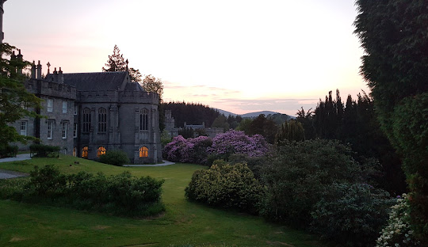

CASTLE FRASER CLUNY CASTLE