**THE GENTLEMAN**

Inscribed to her father the late Group Captain David Huxley who was very active in the Society and is best remembered as MC at Summer School ceilidhs in what used to be the second fortnight. His trademark as MC was an ancient umbrella dangling from his wrist which gave rise to the name of the original tune for the dance – *The Ceilidh Umbrella* composed by Muriel Johnston. The umbrella is preserved at HQ.



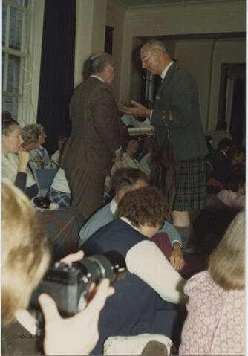

Photograph of Group Captain David Huxley - holding the ceilidh umbrella