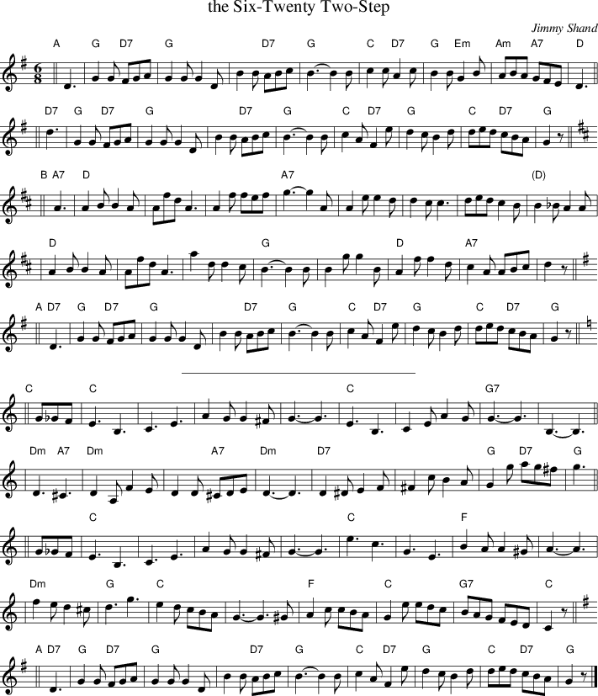

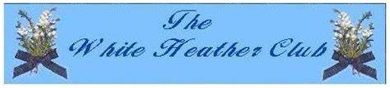

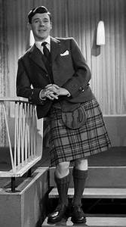 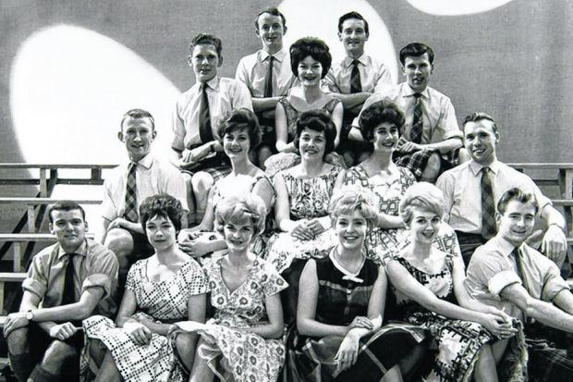

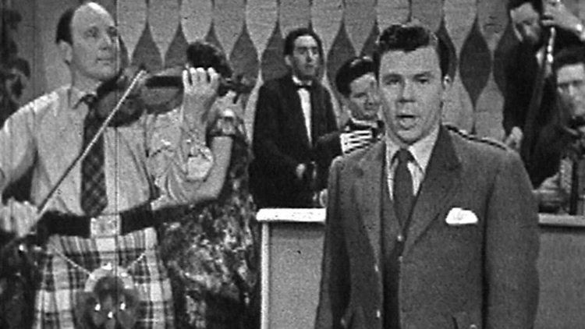 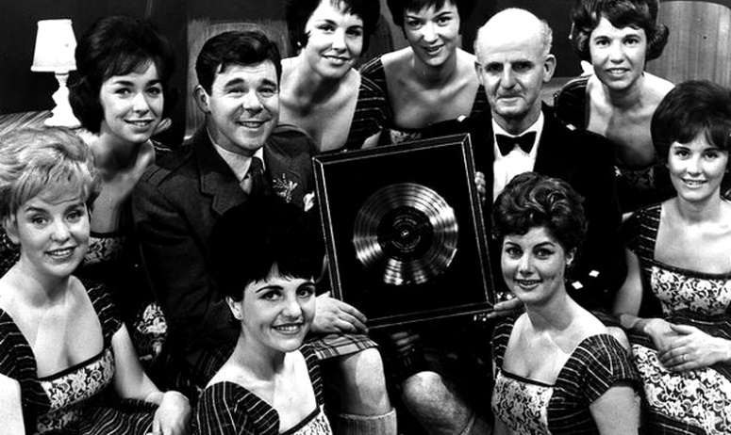

It was an early evening BBC television programme. It started at 6.20, and [Jimmy Shand](https://en.wikipedia.org/wiki/Jimmy_Shand) composed a melody "The Six Twenty Twostep" as the theme tune. This was usually followed by [Andy Stewart](https://en.wikipedia.org/wiki/Andy_Stewart_(musician)) singing "Come in, come in, it's nice to see you...." The show always ended with Andy Stewart and the cast singing, "Haste ye Back":

[Robert Wilson](https://en.wikipedia.org/wiki/Robert_Wilson_(tenor)), who in 1957 had been leading *The White Heather Group*, was an early presenter of the club and recorded with them. The show was so successful that in the early 1960s there was a company touring Scottish theatres, containing many of the performers. The show was broadcast from Glasgow, at that time the only large TV studio in Scotland, and produced by Iain MacFadyen, who went on to become the Head of Light Entertainment for [BBC Scotland](https://en.wikipedia.org/wiki/BBC_Scotland).[[3]](https://en.wikipedia.org/wiki/The_White_Heather_Club#cite_note-andy-3)[[4]](https://en.wikipedia.org/wiki/The_White_Heather_Club#cite_note-4) By the Spring 1961 the series was given an wider audience broadcasting across the UK.

**Hosts**[[edit](https://en.wikipedia.org/w/index.php?title=The_White_Heather_Club&action=edit&section=2)]:

* [Robert Wilson](https://en.wikipedia.org/wiki/Robert_Wilson_(tenor)" \o "Robert Wilson (tenor)) 1957 - 1958
* [Andy Stewart](https://en.wikipedia.org/wiki/Andy_Stewart_(musician)" \o "Andy Stewart (musician)) 1958 - 1964
* Robin Hall and Jimmie Macgregor 1964 - 1968